## Stats Meeting 8th May 2019. Ben M.

1. **Update** – data exploration revealed lots of collinearity between variables → omitted variables → only 1 has substantial number of NAs. These are mostly at ‘start’ or ‘end’ sections of lines and I’m not confident to use mice to interpolate given unknown cross-shelf gradients is a premise of doing this analysis.
   1. Sample size 4 sites = 848 (not including F so no need to omit (many) rows with NAs)
   2. Sample site 3 sites = 642 – 173 F-NAs = 469
2. **Interactions** – e.g. temp and site below
   1. does this mean I can’t include and interaction?
   2. Can I include both at all?
   3. Also look at effects on plotted relationships
3. **Fluorescence~Dbin and Temp~Vbin**
4. **Spatial autocorrelation** (tried gam and gamm)
   1. do I need to include Dbin or Long as main effects?
   2. Interpreting results?
   3. Evaluate by AIC?
   4. 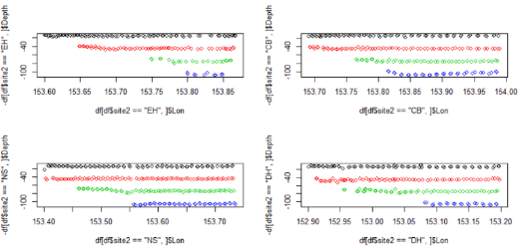Transformation to plot

M10 <- gam(Biomass~s(Temp)+ s(fluorescence)+ s(GA_depth2)+ site2+Dbin,

data=df3, family=Gamma(link="log"), method="REML",

correlation = corGaus(form = ~ Dbin+Lon| site2))

M14 <- gamm(Biomass~

s(Temp)+

s(fluorescence)+

s(GA_depth2)+

site2+Dbin,

data=df3,family=Gamma(link="log"), method="REML")

1. **Variance inflation factors**
   1. Include categorical vars and long? (Long inflates VIF of Temp)

### (2) Temp~site, Temp~Dbin

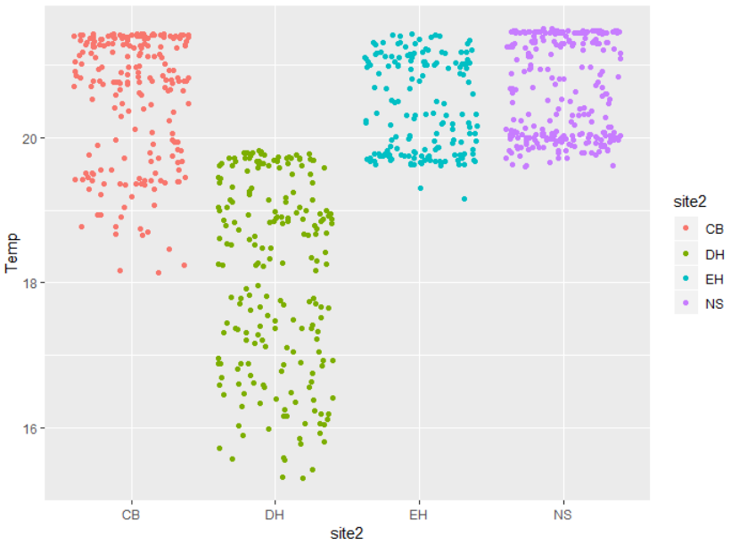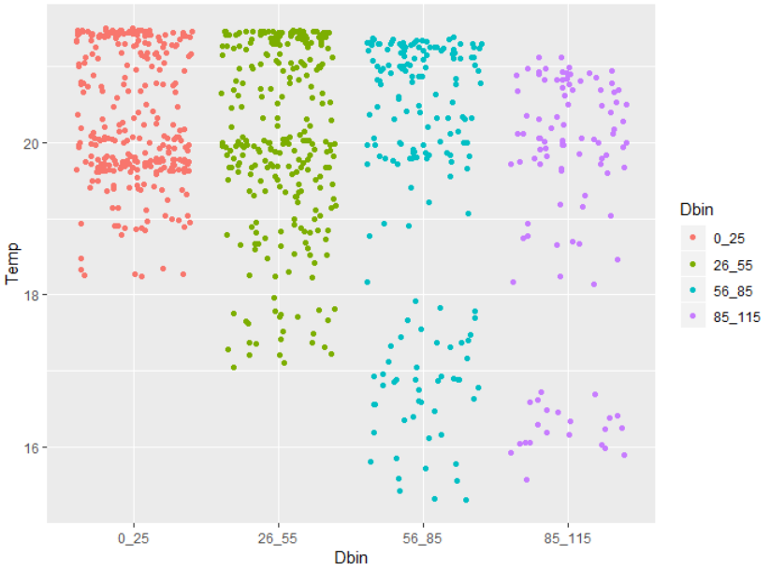

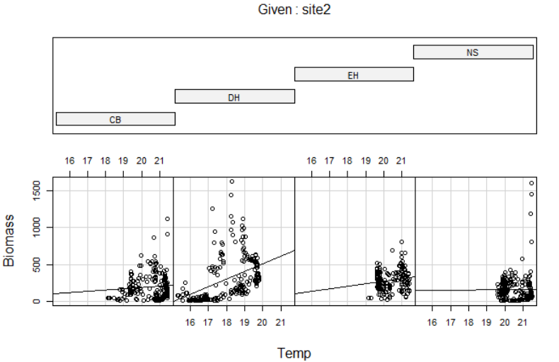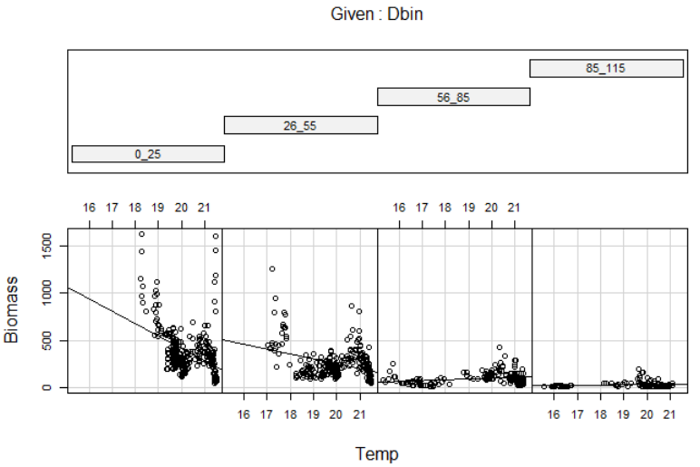

## (2) No interactions

(As above)

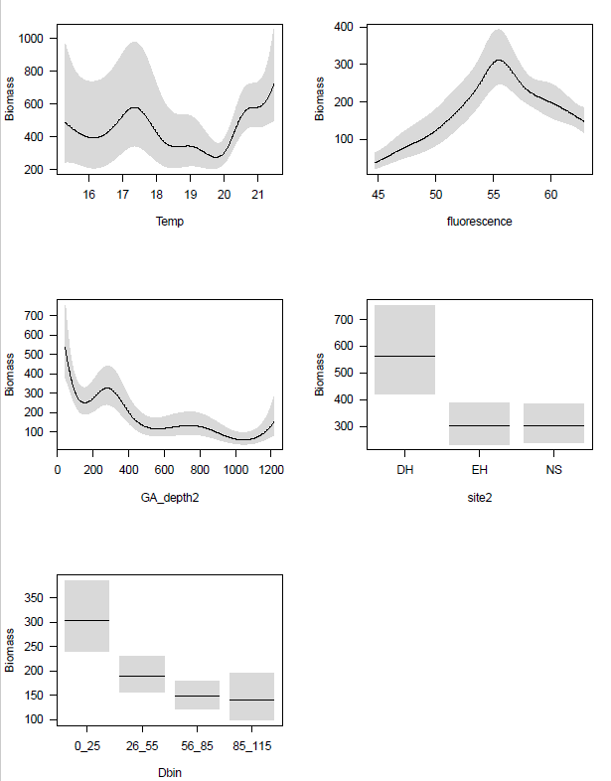

## (2) With site interactions

M11 <- gam(Biomass~

s(Temp, by= site2)+

s(fluorescence, by= site2)+

s(GA_depth2)+

site2+Dbin,

data=df3,family=Gamma(link="log"), method="REML",

correlation = corGaus(form = ~ Dbin+Lon| site2))

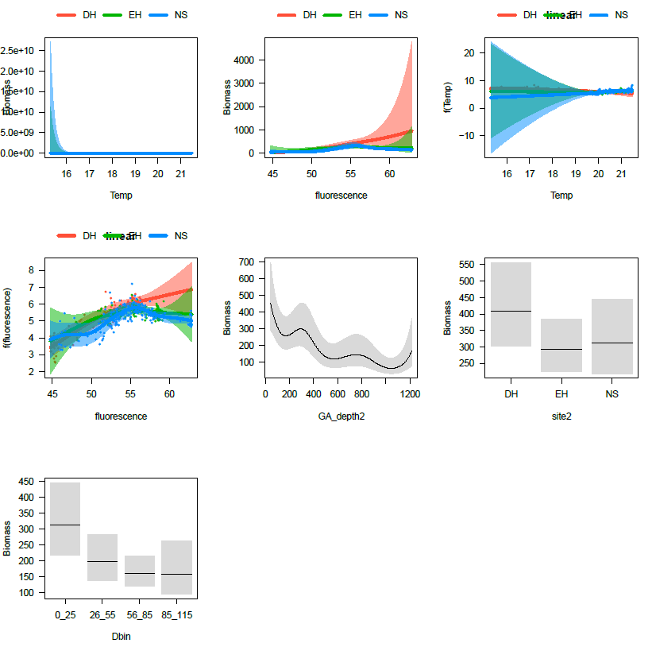

## (2) With Dbin interactions

M12 <- gam(Biomass~

s(Temp, by= Dbin)+

s(fluorescence, by= Dbin)+

s(GA_depth2)+

site2+Dbin,

data=df3,family=Gamma(link="log"), method="REML",

correlation = corGaus(form = ~ Dbin+Lon| site2))

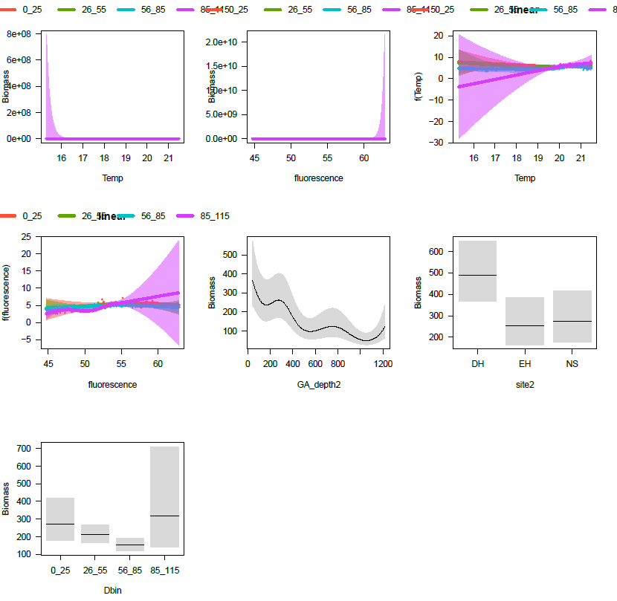

### (3) Fluorescence and Dbin

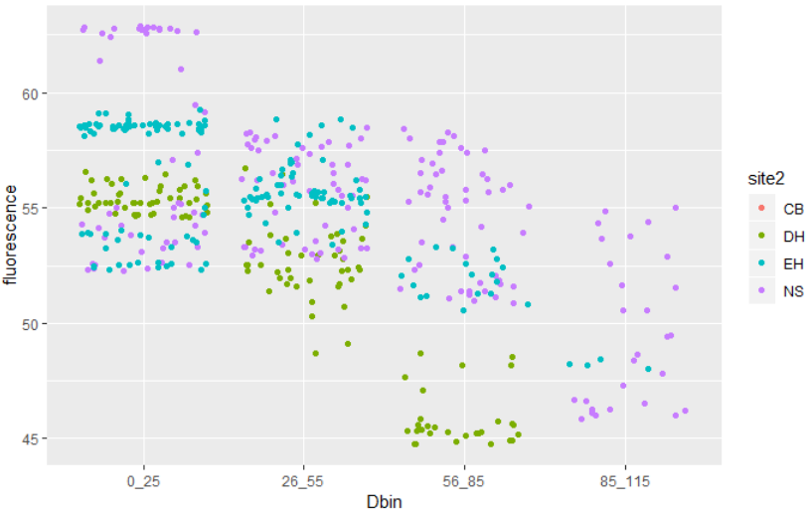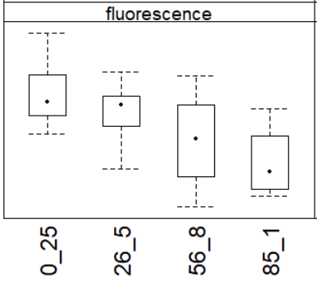

## Temp and Vbin

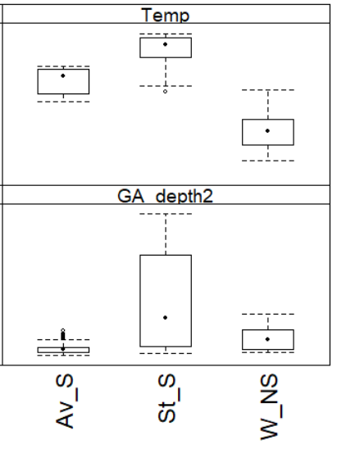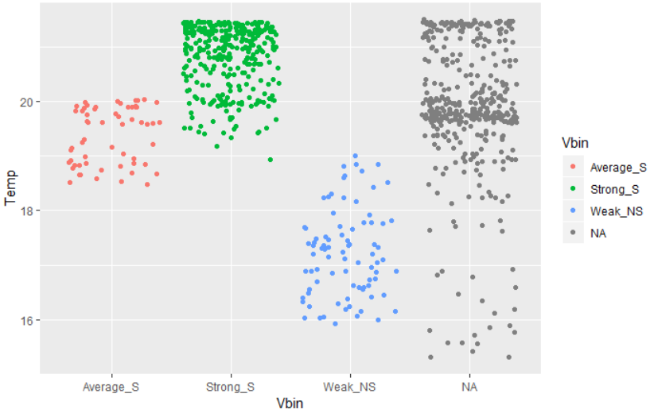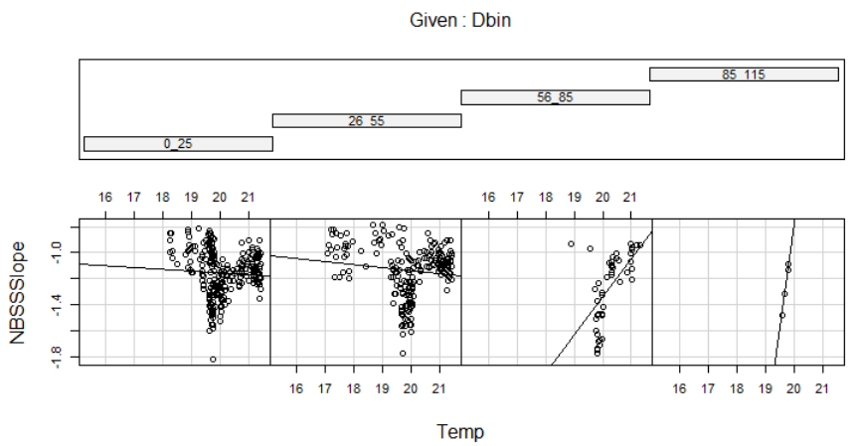

## (4) Spatial autocorrelation with gam

Gam does not recognise ‘correlation’?

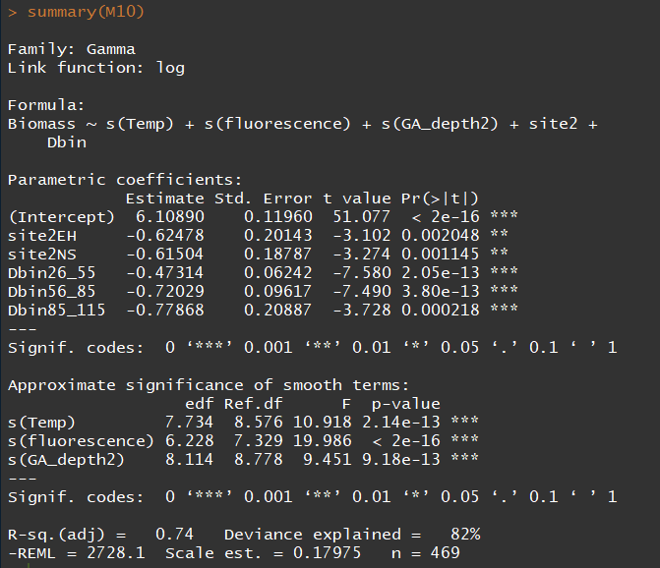

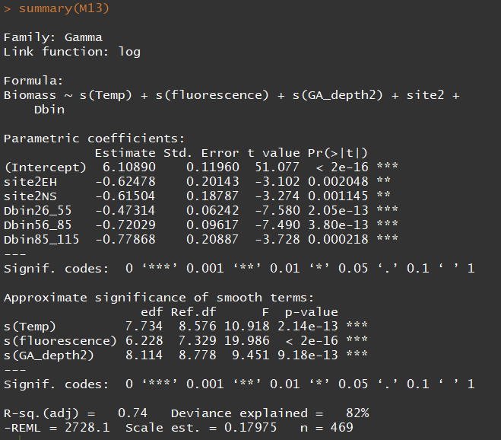

## (4) Spatial autocorrelation with gamm

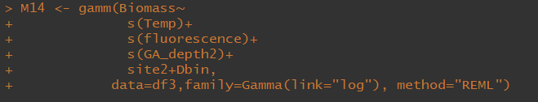

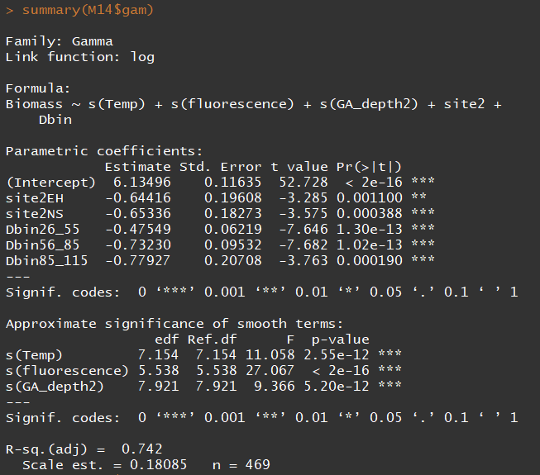

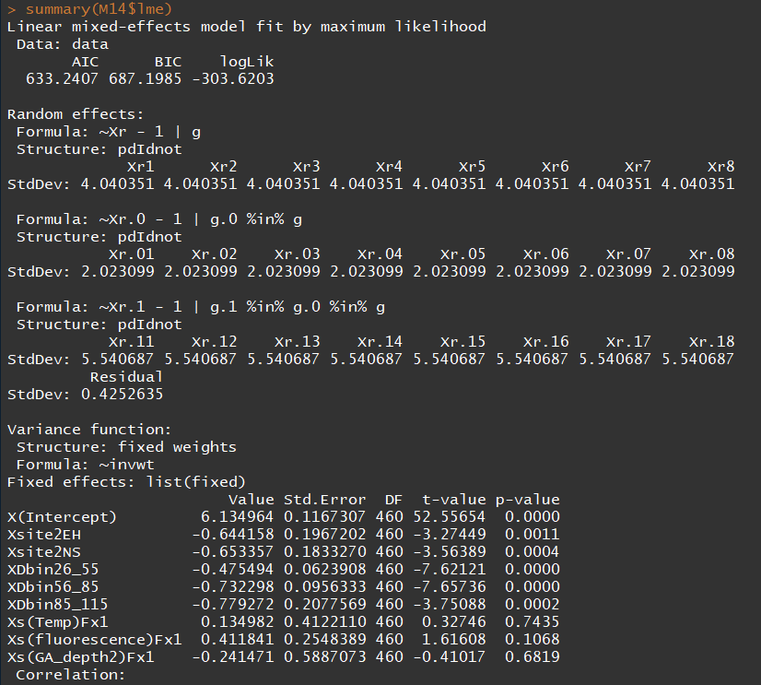 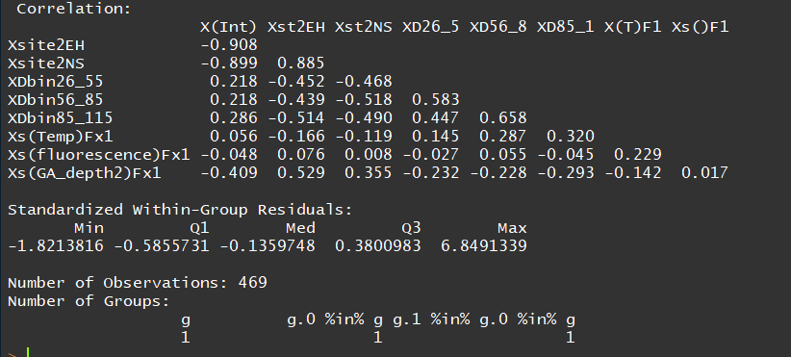

## (4) Plotting GAMM on response scale

visreg(M14$gam, "Temp", scale="linear", line=list(col="black", lwd=1), rug=F)

visreg(M14$gam, "Temp", line=list(col="black", lwd=1), rug=F,trans=Gamma()$linkinv)

visreg(M14$gam, "Temp", scale="linear", line=list(col="black", lwd=1), rug=F,trans=exp, ylab = "Biomass??")

